Directions to Sheboygan South High School
From Manitowoc

Take I - 43 South

Take Exit 123

At the Bottom of the Exit ramp turn left (east, towards the lake)

Continue on this road which turns into Washington street

Continue east until you reach the corner of 12th and Washington streets

Sheboygan South High School is located on this corner

Address: 3128 South 12th Street, Sheboygan WI, 53081

Event Time Site #

BUS #: 1, 2 Departure time from Washington: 6:30 AM

Arrival time back to Washington: 5:00 PM

North High: 1042 School Ave. Sheboygan, WI 53083

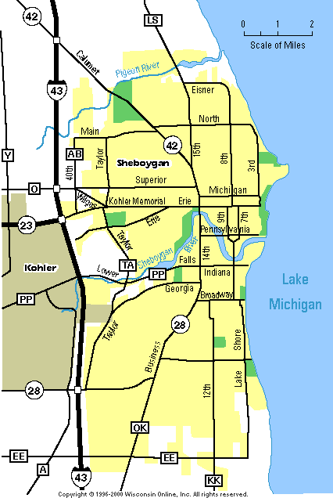

South High: 3128 South 12th Street, Sheboygan WI, 53081

